1. Using ACDC to create the .rsf file to generate the hierarchy of the components and classes.
2. Generate the second .rsf file using our tool.
   1. Find the xml files from the project directory at the repo().

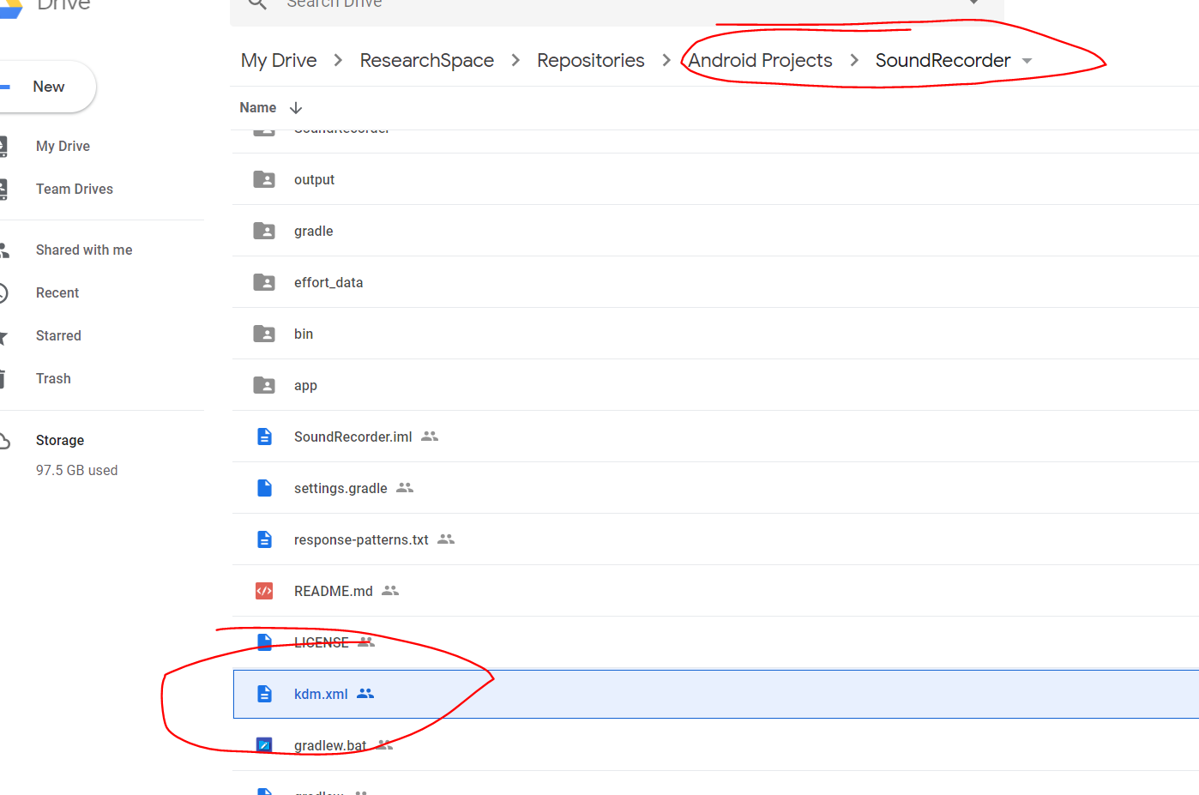

* 1. Run the command line under the root folder of our project:
     1. node ./UMLxAnalyticToolKit.js "[path]/ kdm.xmi" "./debug/output" "export"
  2. Find the cluster file and save it for later use.

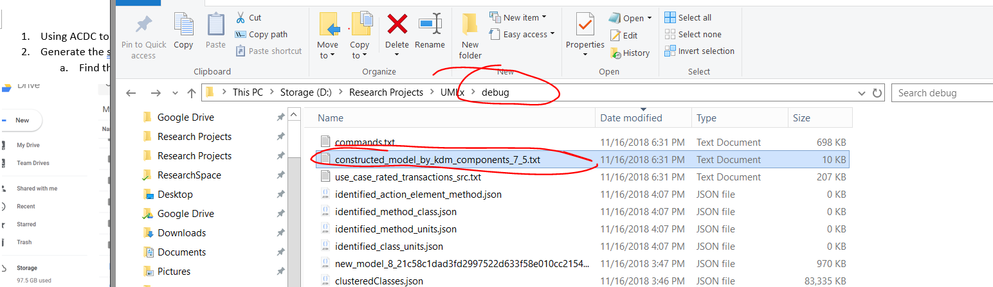

1. Use the .rsf file generated at the 1 step and the file generate in the 2.c step to run MOJOFM to see the comparison results.